計劃書 Version 03
2026-04-14
高雄榮民總醫院人體研究倫理審查委員會
計畫書
- 計畫名稱:
中文：非侵入性脂肪肝和纖維化定量評估整合B-mode US與QUS之多模態深度學習
英文：Multimodal Deep Learning Integrating B-mode US and Quantitative US Features for Non-invasive Fatty Liver and Fibrosis Severity Quantification

- 研究計畫之背景及目的
非酒精性脂肪肝病（NAFLD）的盛行率持續攀升，且其可能進展至肝纖維化甚至肝硬化。傳統的肝臟切片檢查屬於侵入性檢查，可能會對受試者帶來嚴重的風險，並且肝臟切片會因切片部位不同而導致測量偏差；因此開發非侵入性的診斷方法至關重要。
現階段的非侵入性檢測主要有MRI和US等方案，兩者都能對肝臟整體進行檢查。MRI檢測雖然較為準確，然而其檢查成本高昂且費時。超音波比起MRI更具有普遍性且成本較低，不過在準確度方面表現較差。此研究試圖透過成本較低的超音波檢測，達到和MRI檢測一樣地準確精度。
目前超音波有B-mode、Raw Frequency Data、QUS等不同類型的資料，而這三種資料各自有自身的侷限性。B-mode為影像資訊，在產生時進行的掃描轉換會導致大量關鍵資訊流失。QUS為物理聲學資訊，和身體組織有關；不過一般使用者能拿到的只有最終參數，無法拿到完整的parametric map，所以準確度也不盡理想(如Samsung RS85 Prestige使用QUS的檢測表現)。至於Raw Frequency Data，雖然許多文獻都說明其可能取得更好的檢測效果，然而其為限制資料，一般大眾無法取得。
綜上所述，本研究將結合超音波B-mode的影像資訊和QUS的聲學資訊，並使用前沿的電腦視覺預訓練模型進行脂肪肝檢測，最終期望達到和MRI一樣的檢測效果。
- 風險利益評估
（一） 計畫預定執行期間與進度： 2025 年2月15日起至2028年2月14日止，共3年。 （二） 預計回溯病歷區間： 回溯2011年1月1日至2024年12月31日止。
（三） 研究人力/人員及相關設備需求：
計畫主持人1名、共同主持人2名、研究人員1名。
（四） 研究對象數目及納入、排除條件與招募方法：
(1) 研究對象： 年齡大於18歲，在本院接受超音波檢查，懷疑或確認患有與代謝問題相關的脂肪肝疾病，且影像及臨床記錄完整者。
(2) 預計收案數： 規劃收集1000名患有不同程度脂肪肝疾病受試者的影像資料，合計 約4000張影像資料。
(3) 排除條件：
1. 酒精攝取量：每日酒精攝取量超過30克者。
2. 其他肝病：過去診斷為慢性肝炎、B型或C型肝炎、免疫性肝病 或遺傳性肝病患者。
3. 嚴重共病：如晚期心血管疾病、腎功能衰竭或癌症患者。
4. 妊娠或哺乳期：目前懷孕或哺乳中的女性。
5. 最近的肝臟介入：過去六個月內有做過肝臟切片或大型肝臟手術 史。
6. 藥物使用：過去三個月內使用已知會導致脂肪肝或影響肝功能檢 查的藥物。
7. 重複檢查者。
8. 資料缺失：臨床或影像資料不完整者。
(4) 招募方法：採用回溯性資料收集方式。

（五） 研究步驟
本研究為回溯性研究，透過高雄榮民總醫院PACS影像系統與電子健 康記錄 (EHR)，篩選2011年1月1日至2024年12月31日期間進行腹 部超音波檢查的患者，並依據納入與排除標準選取病例組與對照組。所有資料經匿名去連結並以研究號碼取代的方式處理，以保護受試者隱私。
- System architecture：
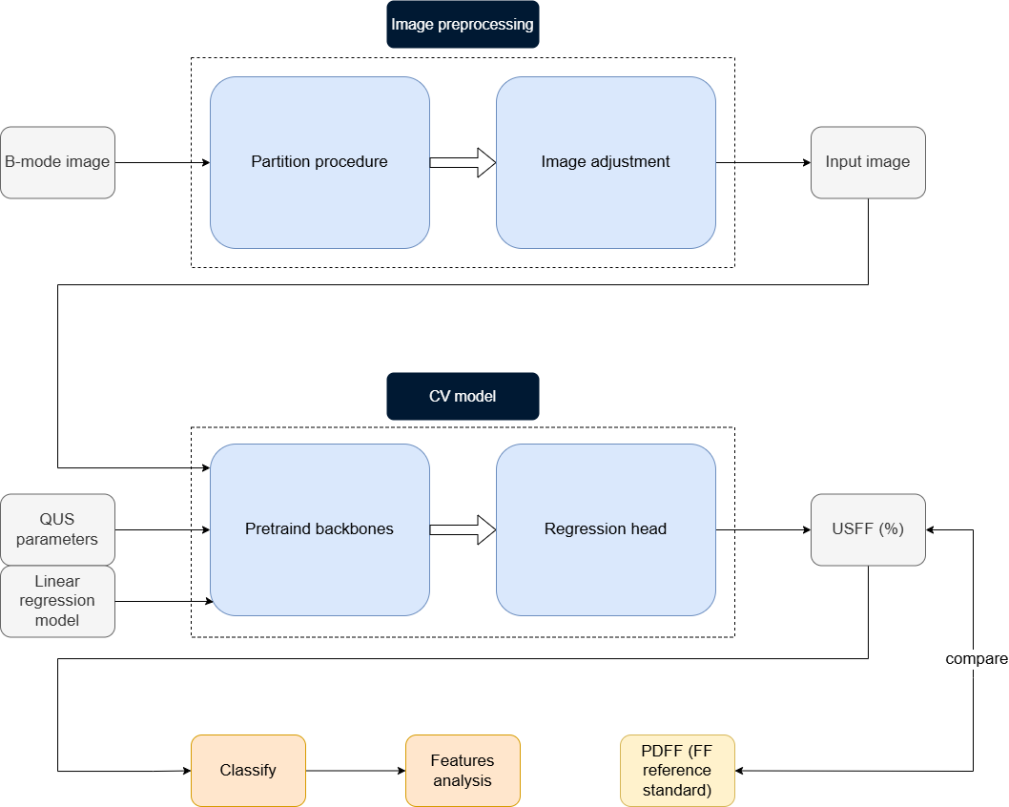
After data collection, B-mode images went through a series of image preprocessing, then images and QUS parameters are inputted into the altered CV model this study design. Upon receiving output data USFF from the CV model, this study compares it with the label PDFF. Finally, this study utilizes comprehensive metrics to measure the accuracy and robustness of the result.
Contribution:
- Developed a pre-trained model that integrates B-mode image and QUS parameters.
- Comparing different QUS parameters and segmentation contributes to accuracy.
- Compared the model’s accuracy with and without segmentation. Utilized Class Activation Mapping (CAM) to provide insights into which regions of liver are most informative for fat quantification.
- Development of a partition algorithm to isolate fan-shape scan region from the background for later augmentation use.
- B-mode image preprocessing
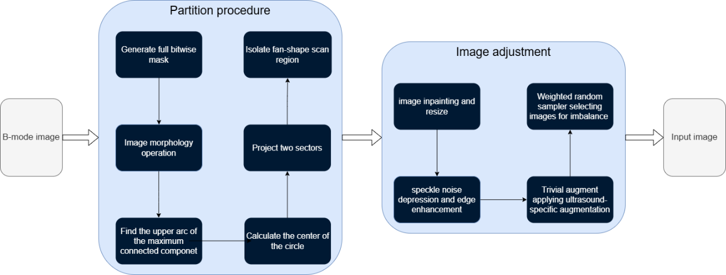
Partition algorithm: to isolate fan-shape scan region: A custom algorithm was implemented to precisely isolate the fan-shaped scan region from the background.
- Bitwise mask & Image closing: A bitwise mask was generated using a threshold of ten, followed by erosion and image closing operations to separate the maximum connected component (i.e., fan shape region) from the background.
- Locate fan shape region: Contour detection was performed using OpenCV to find the maximum connected component. Then, find the upper arc of maximum connected component. After obtaining the upper arc, the center of the circle of this arc. The center of the circle corresponding to this arc was calculated, enabling the projection of two sectors (extending to the upper and lower arcs, respectively) to accurately bound the fan-shaped region within the B-mode data.
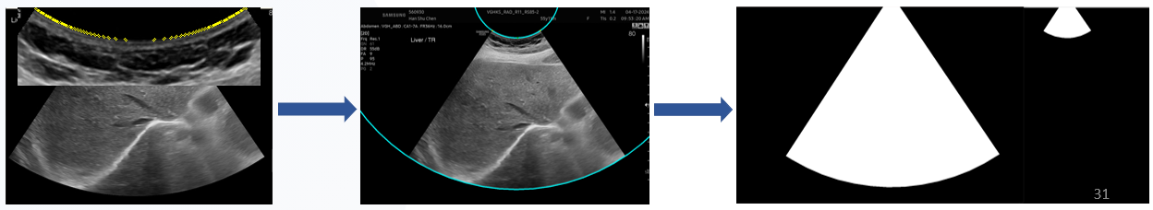
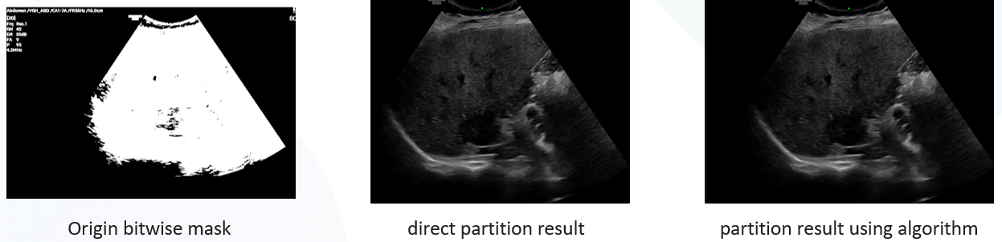
Image adjustment: TAI map artifacts were digitally removed using image inpainting techniques from OpenCV to standardize the images against B-mode data. Subsequently, the images were resized to a standard resolution of 224x224 pixels.
To improve structural clarity, Image Speckle noise depression and edge enhancement function from MATLAB library was perform on the images.
(3) Ultrasound specifically augmentation: To improve model robustness and simulate real-world ultrasound physics, domain-specific augmentation strategies were employed
    - Depth attenuation: mimic the loss of energy of the ultrasound wave energy as it moves through the body
    - Gaussian shadow: mimic acoustic shadows that occur due to air or tissue blocking acoustic waves from penetrating deeper
    - TrivialAugment: Chose the 2 augment techniques above result in best performance as former paper purposed. Randomly select a set of parameters for different augmentation, then applied the augmentation sequentially.
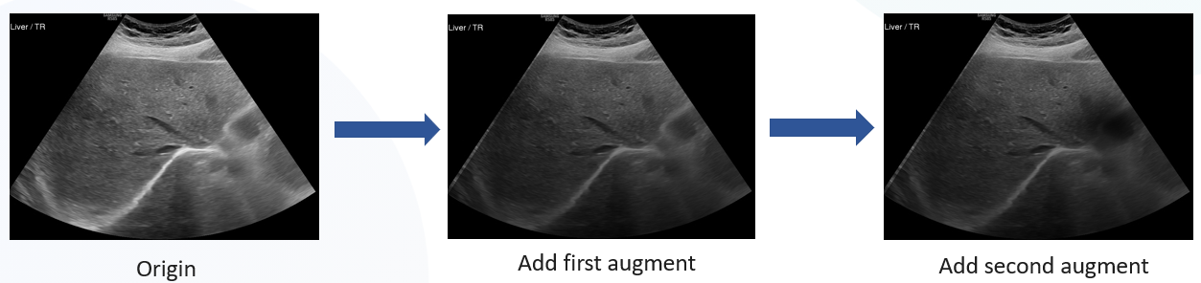
- Model architecture design
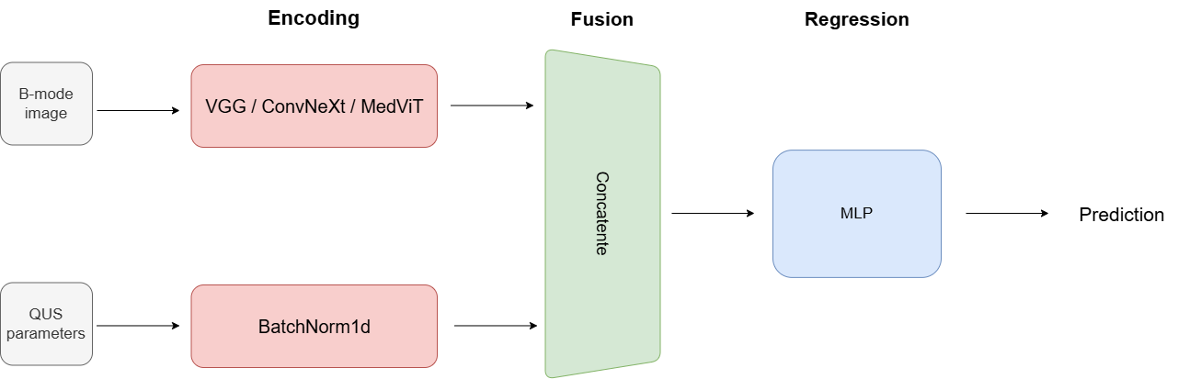
To effectively integrate high-dimensional B-mode images with low-dimensional Quantitative Ultrasound (QUS) scalars, a mid-level fusion strategy was implemented to facilitate multimodal feature interaction.
QUS parameters are scalars, which are way smaller than images in size. To integrate scalars and images, the dimension of images must be reduced, so this study integrates QUS parameters and B-mode image right before the first layer of the regression head, therefore explore multimodal features between them.
Input/Output Layer Modifications:
- The first layer of the pre-trained backbone model was modified to accept 1-channel grayscale inputs, with its weights initialized as the average of the original 3-channel weights.
- The final fc layer of backbone model was substituted with a Identity layer, followed by a Multilayer Perceptron (MLP) configured as a regression head.
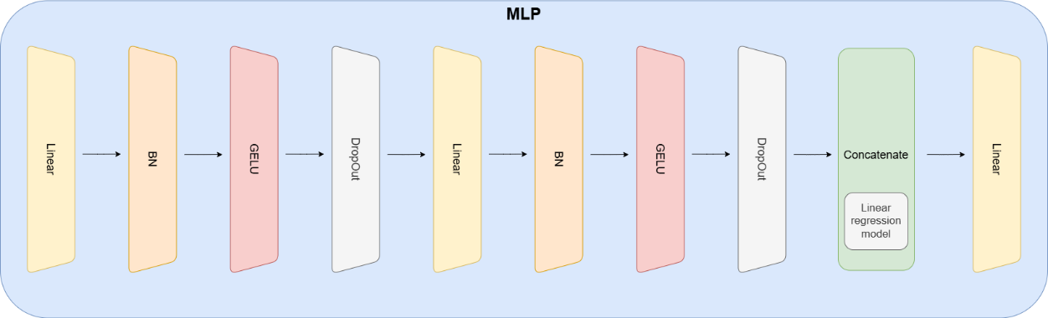
Feature Concatenation
- Image embeddings and scalars were concatenated at the first layer of MLP. Then the regression output was formed through the MLP.
- The prediction of linear regression model was concatenated at the last layer of MLP to provide more information and prevent dilution by large image dimension, and this also works as a mechanism to prevent outliner.
- In training phase, two methods had been designed and validated for merging B-mode image embeddings and QUS parameters. The first method was to adjust the dimension of B-mode image embeddings and QUS parameters separately through a single Linear layer. In this method, the dimension of QUS parameters was adjusted to the closet upper power of two, and the dimension of B-mode image embeddings was adjusted to 8 times of that number. The other method was to concatenate B-mode image embeddings and the QUS parameters into a 1-dimensional vector.
- We evaluate these two methods on validation set. The first method has the overall AUC of 0.94, and the second method has the overall AUC of 0.96. Therefore, the second method was chosen in the concatenation network.
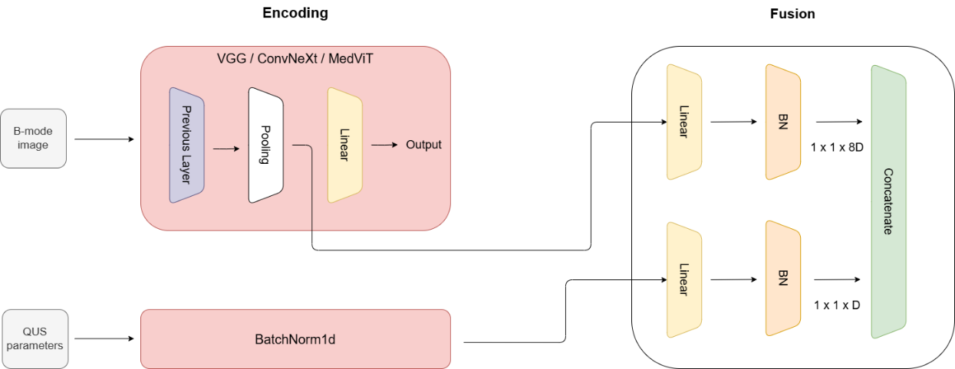
Evaluated Neural Architectures: This study evaluated 3 different neural network architectures (VGG16, ConvNeXt-tiny, MedViT_small) when combining image features and acoustic scalars.
- VGG16: Served as the baseline architecture to facilitate comparisons with prior benchmark studies, specifically for evaluating late fusion and TAI/TSI scalar integration
- ConvNeXt: To overcome the limitation of traditional CNN, ConvNeXt was introduced as the major architecture to extract features from B-mode. ConvNeXt merge the trait from transformers such as large kernels, GELU activation functions, layer normalization, while retraining local texture processing. This model serves to investigate whether a modernized CNN can capture more features in ultrasound image more effectively than VGG.
- MedViT: Beyond convolutional approaches, this study incorporates MedViT, a hybrid medical vision transformer, to investigate the potential of global attention mechanisms. The objective is to experimentally determine whether the transformer's ability to perceive global contextual information can better account for large-scale acoustic attenuation across the liver, thereby potentially surpassing the receptive field limitations of traditional convolutional backbones.
- Model training and testing: A robust, two-phase training protocol was established
to accommodate the newly initialized MLP head and the pre-trained backbone.
- Two-Phase Optimization: During the initial 20 epochs, the pre-trained backbone was frozen while the MLP regression head was still training. After 20 epoch is passed, all layers were unfrozen, and the learning rate of the backbone was scaled down to 10% of the MLP's learning rate to ensure stable fine-tuning.
- The learning rate of the regression head is higher than other layers, because the new regression head needs to learn from the start.
- Hyperparameter Optimization: Learning Rate (LR) finder was utilized to identify the optimal convergence range, paired with cosine annealing to ensure training smoothness
    - Addressing Imbalance and Overfitting: A weighted random sampler was applied to counteract class imbalances within the dataset. Concurrently, the TrivialAugment framework was utilized to guarantee that we do not get the same image twice, thereby mitigating overfitting.
- Self-supervised learning: To leverage unannotated data, ConvNeXt and MedViT models were initially trained using a PDFF labeled dataset. Then we train the model with the rest of the data. We compare the result of self-supervised learning with basic model.
- Segmentation:
1. The specific liver region was segmented from the complete B-mode image. All non-liver background pixels are set to 0, and the images were cropped to only contain liver region.
2. When input Segmented image in the model, the procedure is the same as normal b-mode image.
- Interpretability: Class Activation Mapping (CAM) was employed across VGG16, ConvNeXt-tiny, and MedViT_small to visually identify the specific hepatic regions driving the models' feature extraction and prediction.
- Ablation Studies: comparison between different pretrained model(VGG, ConvNeXt, MedViT)
  - B-mode only: Baseline of the study. It’s used to evaluate the limit of neural network to extract features from B-mode liver image.
  - B-mode + TAI, TSI, linear regression model: Explore multimodal features between B-mode image and former-proved effective QUS parameters, also introduce acoustic prior knowledge (linear regression model).
  - B-mode + 4 QUS parameters, linear regression mode: Introduce more QUS parameters, testing whether more QUS parameters will improve accuracy.
  - B-mode with Segmentation + 4 QUS parameters, linear regression mode: Make the model focus on liver region and see whether the accuracy will improve.
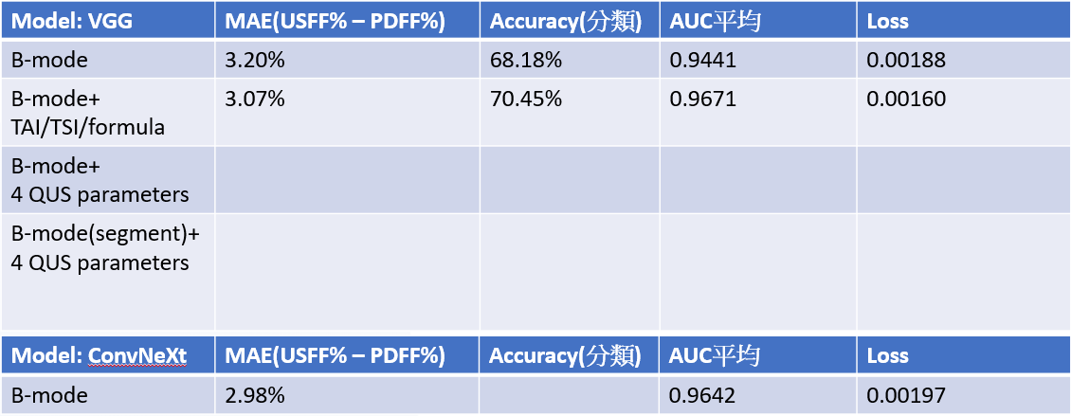
（六） 研究對象權益之保障、同意之方式及內容：
本研究屬最低風險，對研究對象之可能風險不超過未參與研究者，且免 除事先取得同意並不影響研究對象之權益，故申請免除知情同意。

- 統計分析方法
  - Calculated Pearson correlation coefficient to evaluate the USFF and MRI PDFF correlation
  - Evaluated $R^{2}$ using linear regression analysis. Use Bland-Altman analysis with 95% limits
of agreement
  - The predictive performance was quantified using the Mean Absolute Error (MAE) between the estimated values and ground truth.
  - To evaluate the model, we reported the overall accuracy derived from the confusion matrix.
  - The probability scores obtained in each validation fold were grouped, and a single ROC analysis was performed to obtain an AUROC for the entire participant population.
  - Optimal cutoff values for USFF are determined using the maximal Youden index, with performance parameters including sensitivity, specificity, PPV, NPV, for evaluating hepatic steatosis based on MRI-PDFF.

- 風險利益評估
本研究在風險利益評估中，屬第一類風險：相當於微小風險。這類風險被視為可以接受的，因為它們不會對參與者造成顯著的健康風險或 不適。研究團隊將全力以赴，並在進行這項研究時，嚴謹地遵循科學原則，保護受試者的安全、權益與隱私。並透過有效的風險管理與監測機制，以達到研究 的預期效益，同時最大程度地減少可能的風險。我們深信，這樣的努力將使 我們的研究能夠產生有意義且可信賴的結果。

- 預期研究結果
本研究預期將建立一個高效且準確的深度學習模型，能夠自動診斷脂肪肝和纖維化並精確標記病變位置，顯著減少臨床診斷中的人力消耗與誤診率。通過收集並 4 計劃書 Version 03 2025-04-14 處理約4000筆影像資料，涵蓋MRI及超音波圖像，研究將構建一個全面的脂肪肝影像資料庫，用於模型的訓練與驗證。我們將通過多項評估指標 （如Pearson correlation coefficient、MAE、Overall AUC、Sensitivity、Specificity、PPV,、NPV、bland_altman graph）對模型進行全面檢驗，以確保其對脂肪肝病變區域的精確分割與分類能力。
最終，本研究預期能提供一個穩健且可應用於臨床的非侵入性診斷工具，提高脂肪肝和肝纖維化診斷的準確性和效率，並促進患者的早期診斷與優化治療方案，從而提升其生活品質。

